Week 1 - PYTHON BASIC PRACTICE – I

NAYAKANTI SAI MIHIRNATH – 210905368

1> Assigning Values to a variable

counter = 100
miles = 1000.0
name = "Mihir"
print(counter,miles,name)
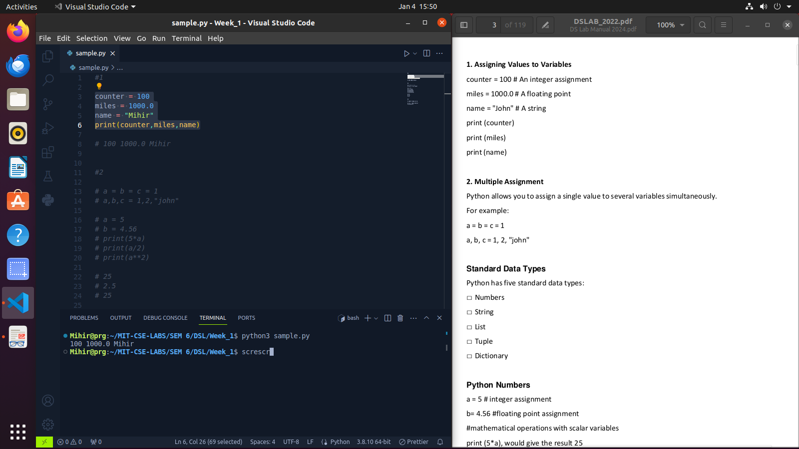

2> Multiple Assignment and Numbers

a = b = c = 1
a,b,c = 1,2,"john"
a = 5
b = 4.56
print(5*a)
print(a/2)
print(a**2)
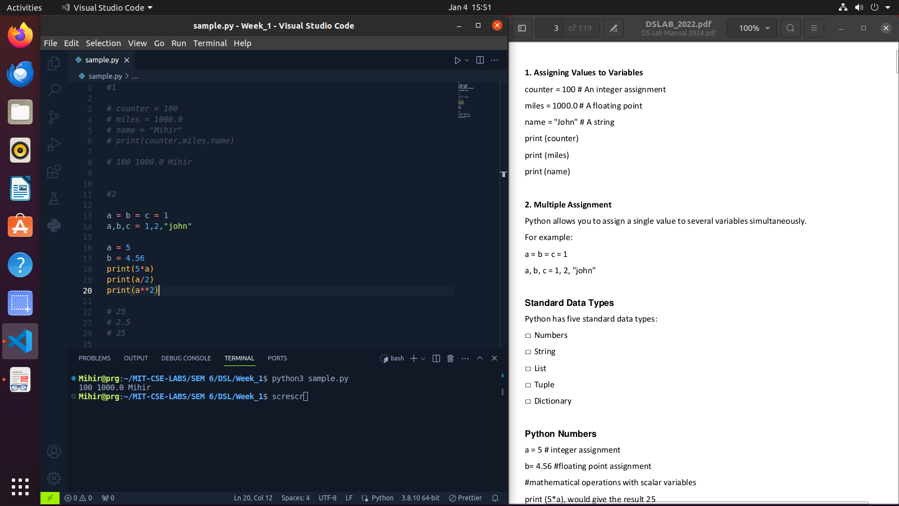

3> Numpy and Strings

import numpy as np

str = 'Hello World!'
print (str)
print (str[0])
print (str[2:5])
print (str[2:])
print (str * 2)
print (str + "TEST")

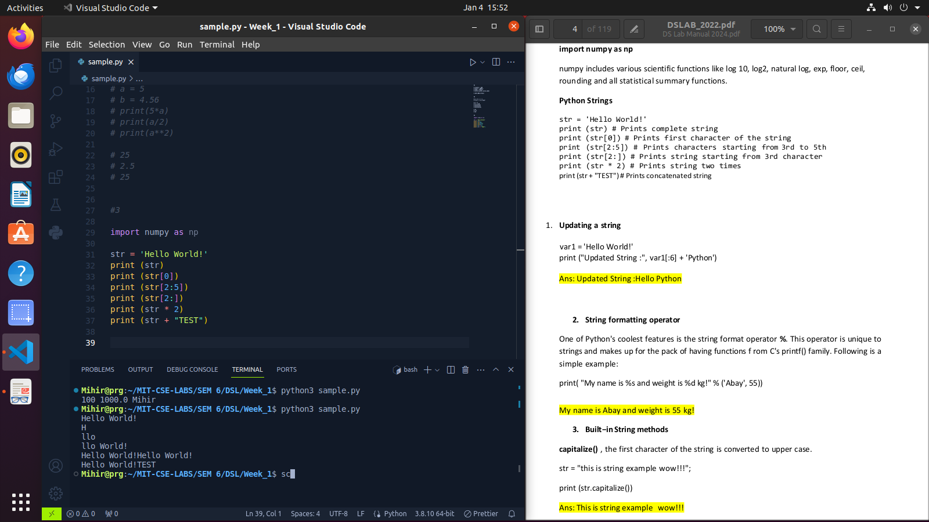

4> String Methods

var1 = 'Hello World!'
print ("Updated String :", var1[:6] + 'Python')
print( "My name is %s and weight is %d kg!" % ('Abay', 55))
str = "this is string example wow!!!";
print (str.capitalize())
str = "this is string example ... wow!!!";
str.count('s')
str.find('example')
str = "this is string example ... wow!!! this is really string";
print (str.replace("is", "was"))
str = "this is string example ... wow!!!";
print (str.swapcase())
str = "this is string example ... wow!!!";
print (str.title())

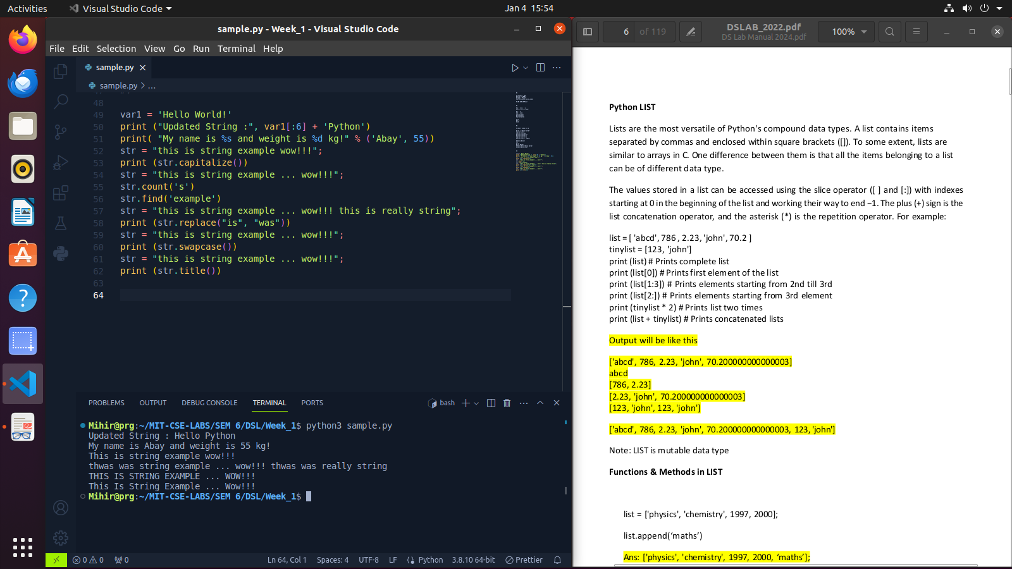

5> Lists

list = [ 'abcd', 786 , 2.23, 'john', 70.2 ]
tinylist = [123, 'john']
print (list)
print (list[0])
print (list[1:3])
print (list[2:])
print (tinylist * 2)
print (list + tinylist)
list = ['physics', 'chemistry', 1997, 2000];
list.append('maths')
del list[2]
len(list)
list.count('physics')
list.pop()
print(list)
list.insert(2, 'maths')
print(list)
list.remove('chemistry')
print(list)
list.reverse()
print(list)

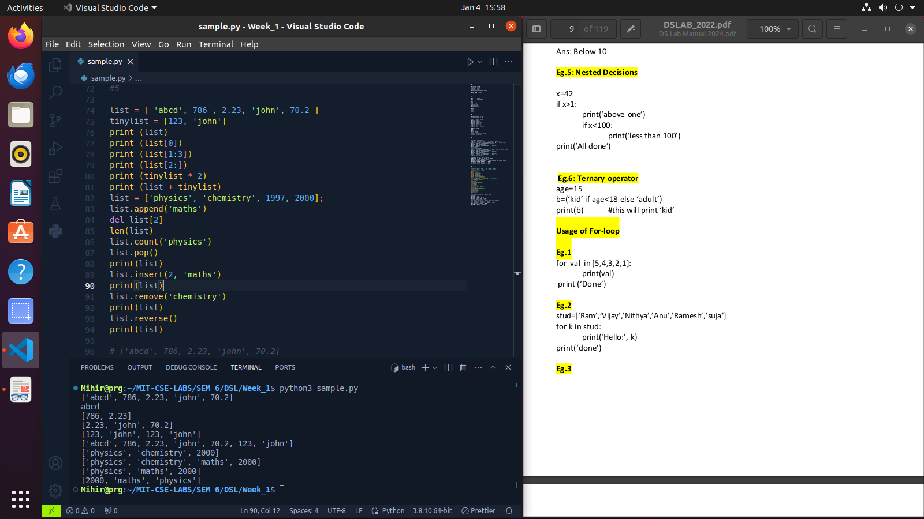

6> Tuples

tuple = ( 'abcd', 786 , 2.23, 'john', 70.2 )
list = [ 'abcd', 786 , 2.23, 'john', 70.2 ]
tuple[2] = 1000
list[2] = 1000

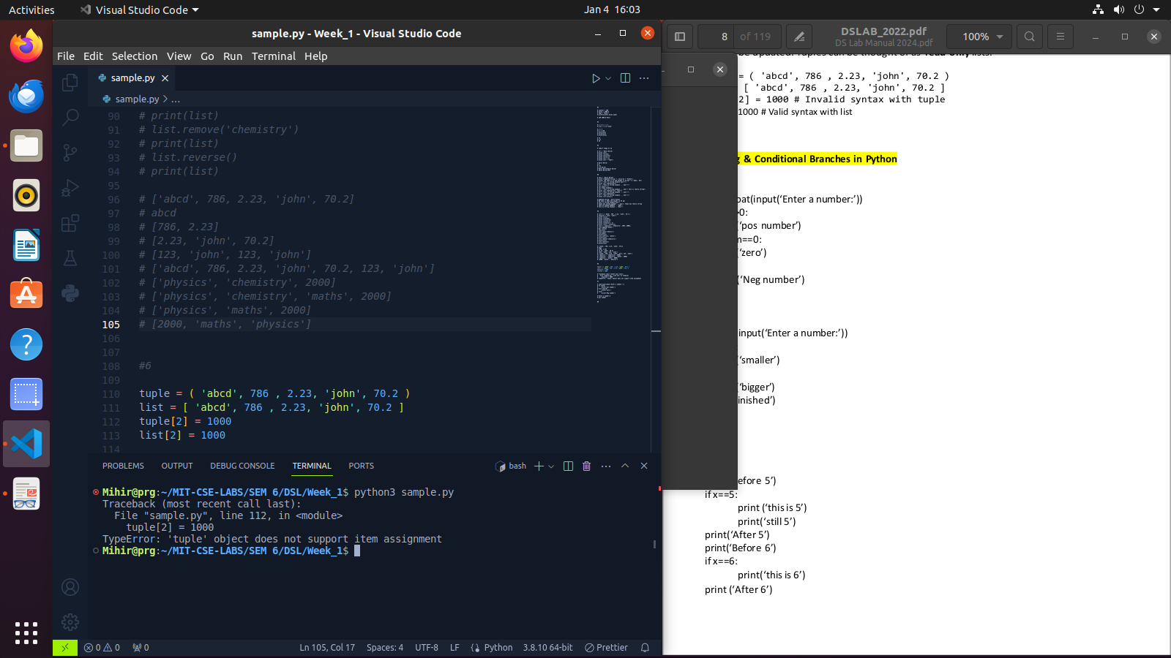

7> Conditional Branch

num=float(input('Enter a number:'))
if num>0:
print('pos number')
elif num==0:
print('zero')
else:
print('Neg number')
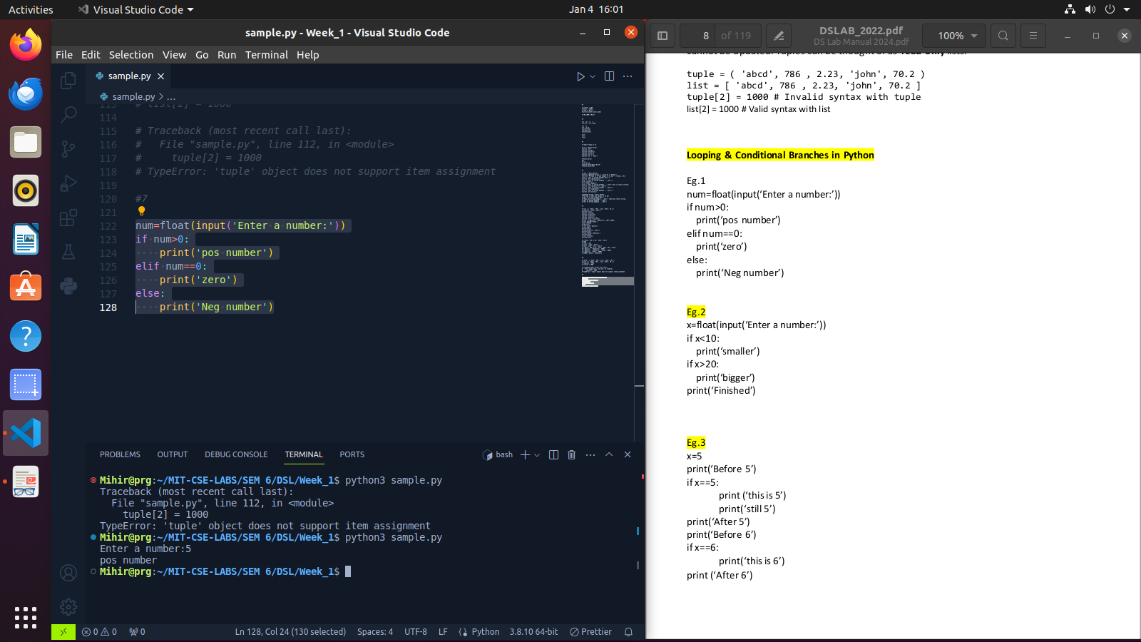
8> Nested Desicions

x=42
if x>1:
print('above one')
if x<100:
print('less than 100')
print('All done')

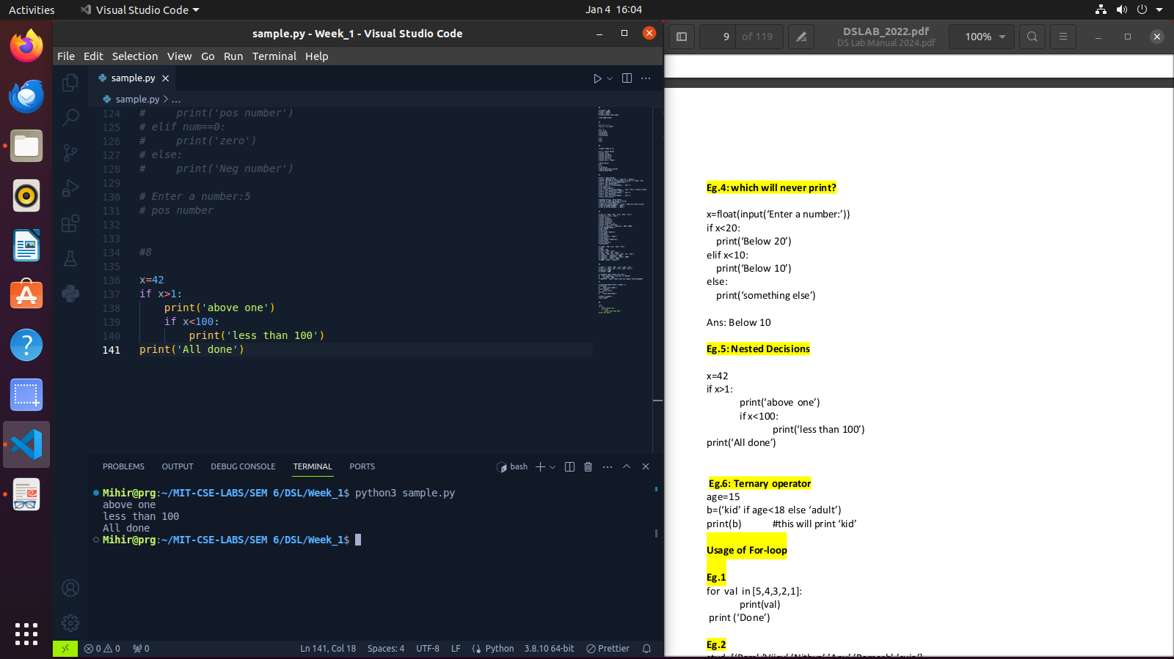

9> Ternary Operator

age=15
b=('kid' if age<18 else 'adult')
print(b)
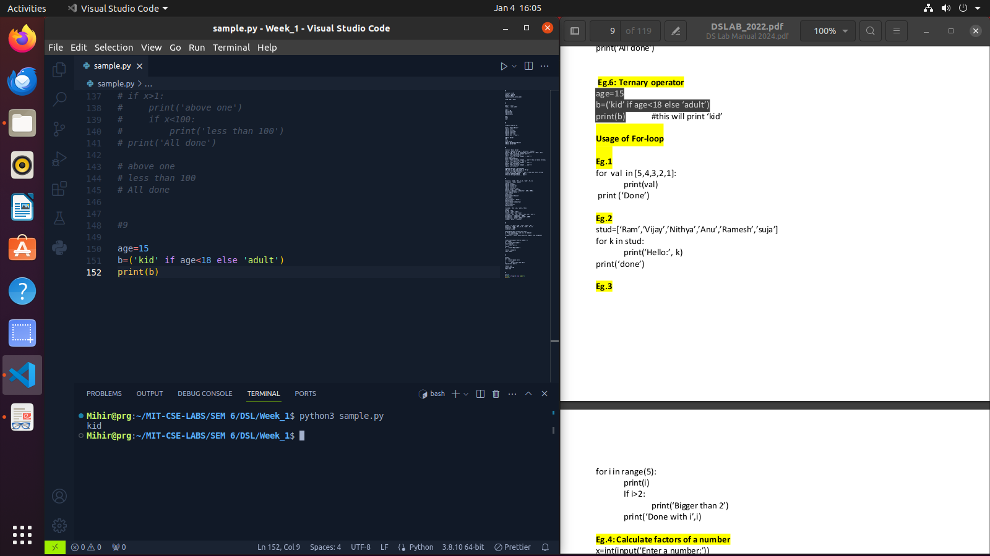
10 > For Loop

stud=['Ram','Vijay','Nithya','Anu','Ramesh','suja']
for k in stud:
print('Hello:', k)
print('done')

